Dissemination Pack (Email)
Sustainable Aquaculture Call

Options:
Newsletter Paragraph - Aquaculture Call 0
Pre-made Email for Internal Dissemination 1

Newsletter Paragraph - Aquaculture Call
The AQUASERV Sustainable Aquaculture Call is now open, offering funded access to more than 60 leading research facilities across Europe. The call supports innovative research projects (up to 3 months) addressing key challenges in sustainable aquaculture, including feed innovation, animal health, waste management, product quality, and contributions to the EU Farm to Fork Strategy. Applications are open to academic and industry researchers at all career stages.
🗓 Deadline: 31 March 2026
🔗 Learn more and apply: https://www.aquaserv-ri.eu/transnational-access-call

If relevant, image options:
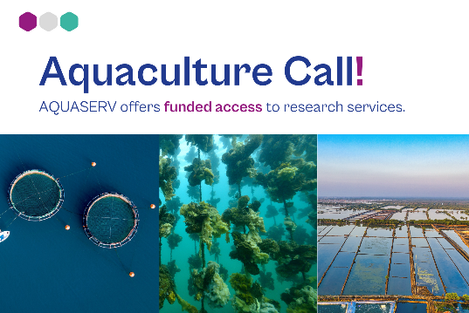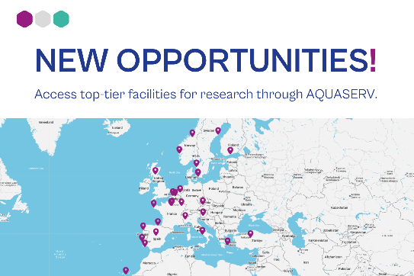

Pre-made Email for Internal Dissemination
Dear Colleagues,
With a new year beginning and new goals ahead, we would like to remind you of what AQUASERV and our institution can offer.
Through AQUASERV, researchers from both academia and industry can gain funded access (up to 3 months) to some of Europe’s most advanced research facilities, including ours. The project fully or partially covers travel, accommodation, and laboratory consumables, enabling high-quality research supported by international collaboration. AQUASERV brings together a network of leading research infrastructures that open their doors to advance work across multiple aquatic research fields and strengthen cross-border scientific cooperation
• Service catalogue: https://www.aquaserv-ri.eu/transnational-access
• Eligibility information: https://www.aquaserv-ri.eu/who-can-apply
AQUASERV currently offers two access opportunities:
4th round of submission for Transnational Access
- Supporting excellent research across all aquatic science fields.
- This call is always open, with periodic decision rounds in March, July, and November.
🔗 https://www.aquaserv-ri.eu/transnational-access-call
Sustainable Aquaculture Call
- A thematic call supporting innovative research projects in sustainable aquaculture.
- 🗓 Deadline: 31 March 2026
🔗 https://www.aquaserv-ri.eu/aquaculture-call
AQUASERV is also offering guidance.
To strengthen your proposal and increase your chances of securing funded access, you are invited to join our upcoming online Info Session for prospective applicants.
👉 Register here: https://www.aquaserv-ri.eu/aquaculture-call
Kind regards,

