Dissemination Pack (Social Media)
Sustainable Aquaculture Call

Partners are encouraged to tag @AQUASERV when sharing posts related to this call. If you produce videos or visual content promoting your facilities in connection with AQUASERV access, please share them with us so they can be featured on the AQUASERV website and channels.

Pre-made Social Media Posts
Calls & Info Session Promotion 1
Advertise the Open Call 2
Advertise Aquaculture Call 3
Advertise Your Institution To New Users (General) 4

Calls & Info Session Promotion
What is AQUASERV and how can it support your research?
AQUASERV provides access to some of Europe’s most advanced research facilities, including ours. This enables researchers to carry out high‑quality projects through international collaboration at almost no cost to the user.

Right now, AQUASERV has two opportunities available:
👉 A specific call targeting sustainable aquaculture research (Deadline: March 2026): https://www.aquaserv-ri.eu/aquaculture-call
👉 A general call accepting excellent research proposals in aquatic sciences (Always Open): https://www.aquaserv-ri.eu/transnational-access-call

If you’re interested, AQUASERV is hosting an upcoming info session where the team will explain everything you need to know about the offer and the application process. You can register directly on either of the pages above.
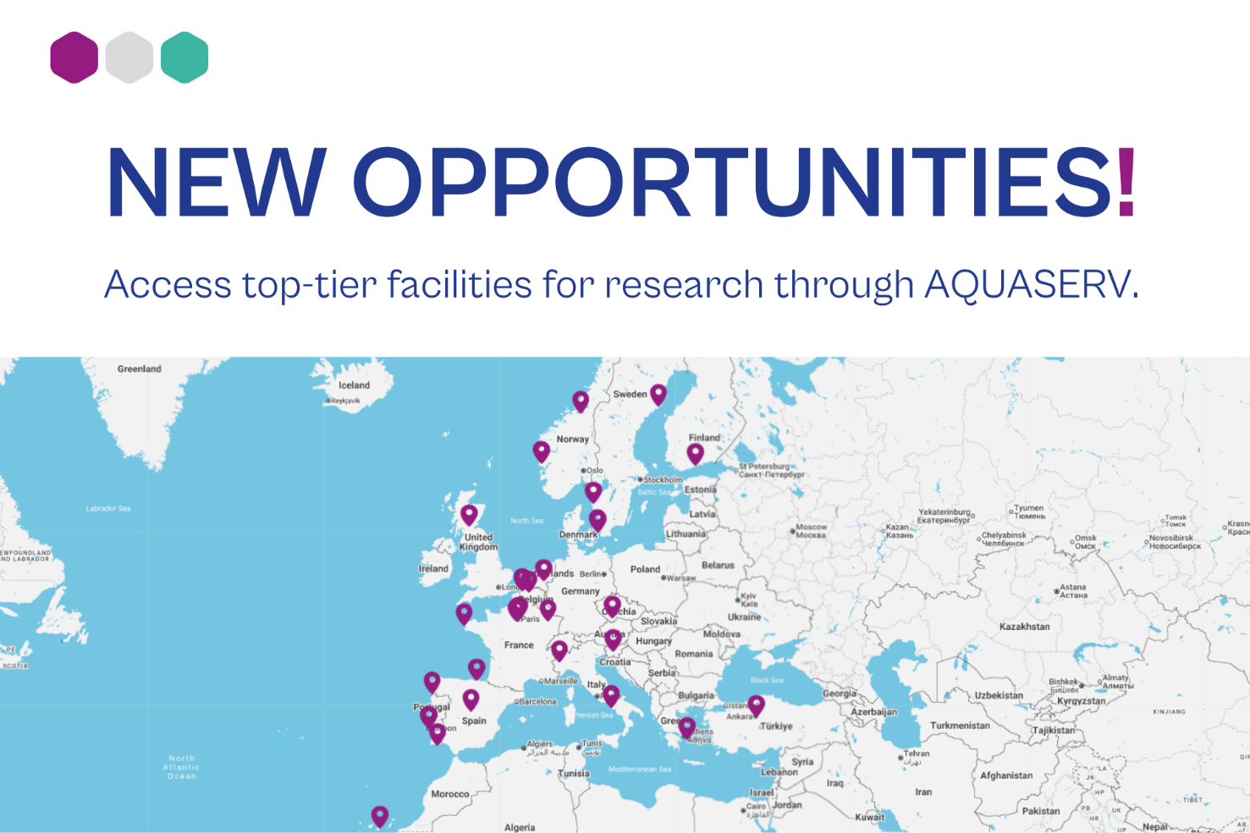

Advertise the Open Call
Do you want to take your research further and collaborate internationally?
Being part of the @AQUASERV project, means our facility is part of a network of leading European research infrastructures that are opening their doors to take research to the next level and build more international collaboration.
👉 What does this mean for you? It means you can apply, benefit from our partners' state-of-the-art facilities and collaborate internationally. All, with your travel, accommodation and lab consumables fully or partially covered. Browse the catalogue: https://www.aquaserv-ri.eu/transnational-access
👉 Who is it for? Researchers from inside and outside the EU with research proposals in aquatic research areas such as sustainable aquaculture, fisheries, ecological restoration, blue economy, food security, biotechnology, ecosystem health, pollution, etc. The programme offers the flexibility to explore bold, high-impact ideas that address European policy priorities.
📅 When can you apply? The call is always open, but proposals are reviewed in March, July and November each year, so make sure you get your application in before then.
🔗 Check out the AQUASERV website and contact the team if you have any questions: https://www.aquaserv-ri.eu/transnational-access-call
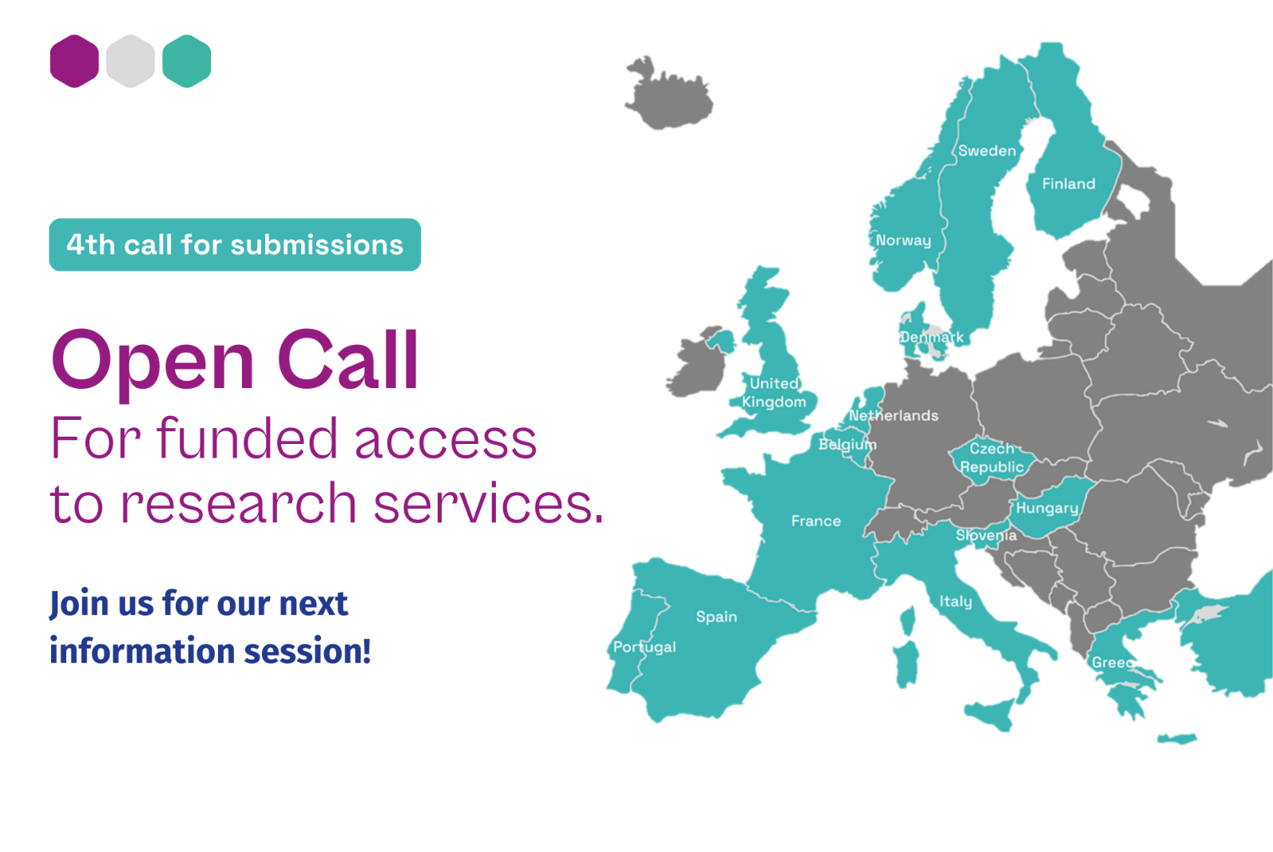

Advertise Aquaculture Call
The Sustainable Aquaculture Call is NOW OPEN!
Through @AQUASERV, researchers from academia and industry can access a network of over 60 leading research infrastructures, including ours! Costs are fully or partially covered, including those for facilities, standard consumables and, where relevant, travel and accommodation.
This call welcomes innovative research projects of up to 3 months. If your research addresses sustainable aquaculture, from innovative feeds and health management to waste reduction and Farm to Fork priorities, this call is for you.
📅 Deadline for submission: 31 March 2026
🔗Explore services, contact an Access Manager, and apply: https://www.aquaserv-ri.eu/aquaculture-call
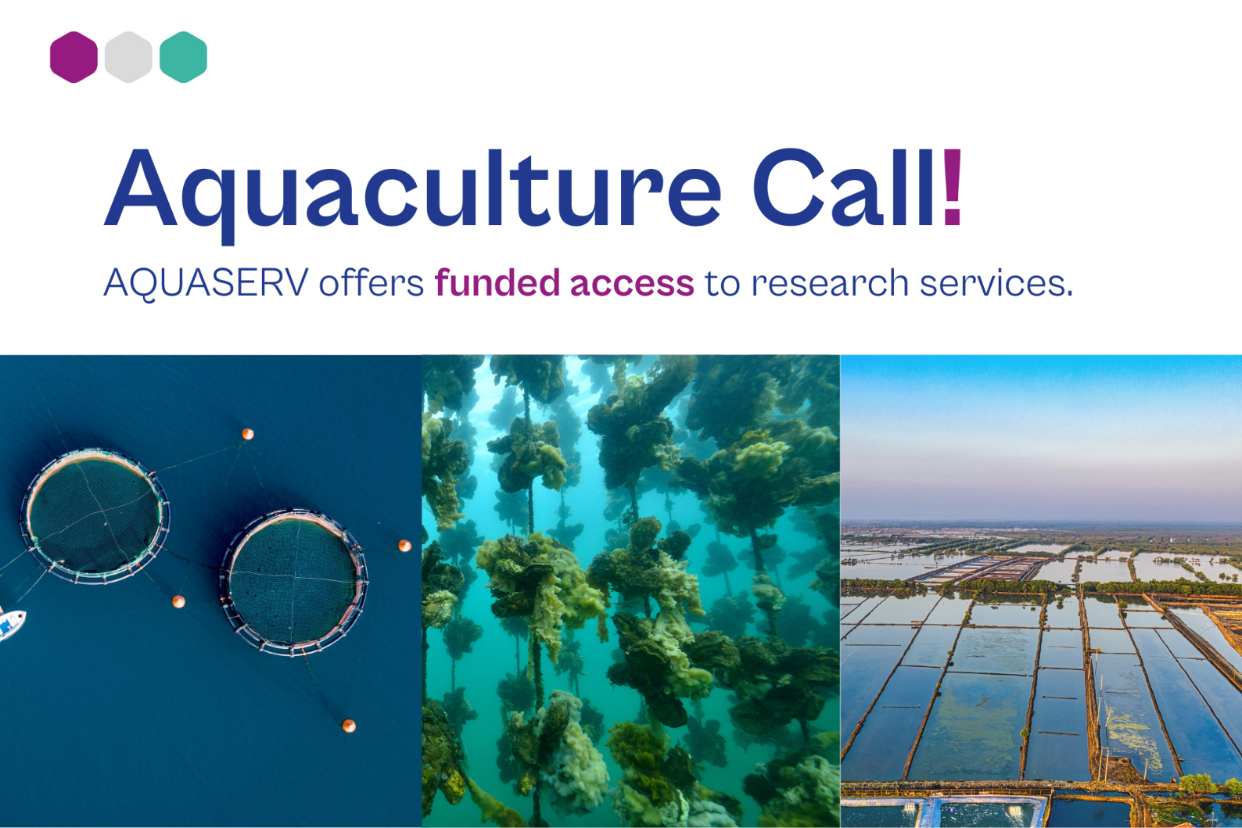

Advertise Your Institution To New Users (General)
We’re starting the year by giving you the opportunity to take your research to the next level using our state‑of‑the‑art facilities. Through @AQUASERV, we are part of a network of leading European research infrastructures that welcome researchers to their facilities. Once your project is selected, AQUASERV will fully or partially cover your travel, accommodation, and laboratory consumables.
👉 If you are an EU or non‑EU researcher with aquatic research proposals that can contribute to European policy priorities, don’t hesitate to apply. We currently have two calls open until March 2026.
🔗 Explore our services and contact our Access Manager:https://www.aquaserv-ri.eu/transnational-access/centro-de-ci%C3%AAncias-do-mar-do-algarve

(For this post we suggest you use some pictures of your services and mention AQUASERV)

